**Name – Aniket Narale**

**JUnit&Mockito**

**Q1.** Write a class called MinMaxFinder. Define a method in it called findMinMax() which accepts an int array and returns new array of size 2, wherein the 0th index will have the min value of the array and 1st index will have max value of the array. Perform Junit testing of the method findMinMax with as many test cases you can think of (min 3 test cases)

E.g.

MinMaxFinder.findMinMax( new int[]{56, 34, 7,3, 54, 3, 34, 34, 53} ); should return a new array with min and max values {3, 56} at 0th and 1st index respectively.

**Created Main Class as well as Test class for the same:**

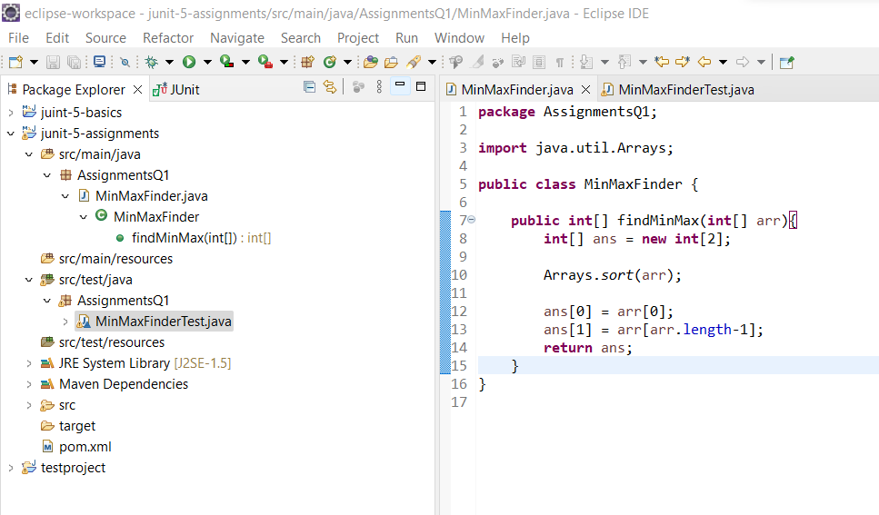

**Main Class Code:**

**package** AssignmentsQ1;

**import** java.util.Arrays;

**public** **class** MinMaxFinder {

**public** **int**[] findMinMax(**int**[] arr){

**int**[] ans = **new** **int**[2];

Arrays.*sort*(arr);

ans[0] = arr[0];

ans[1] = arr[arr.length-1];

**return** ans;

}

}

**Test Class Code:**

**package** AssignmentsQ1;

**import** **static** org.junit.jupiter.api.Assertions.*;

**import** org.junit.jupiter.api.AfterEach;

**import** org.junit.jupiter.api.Assertions;

**import** org.junit.jupiter.api.BeforeEach;

**import** org.junit.jupiter.api.Test;

**import** AssignmentsQ1.MinMaxFinder;

**class** MinMaxFinderTest {

**private** MinMaxFinder minMaxFinder;

**private** **int**[] expected;

**private** **int**[] actual;

@BeforeEach

**public** **void** init(){

minMaxFinder = **new** MinMaxFinder();

expected = **new** **int**[]{3, 56};

}

@Test

**public** **void** TestminMaxFinder(){

actual = minMaxFinder.findMinMax(**new** **int**[]{56, 34, 7,3, 54, 3, 34, 34, 53});

Assertions.*assertArrayEquals*(expected,actual);

}

@AfterEach

**public** **void** Clean(){

minMaxFinder = **null**;

expected = actual = **null**;

}

}

**Testing Output:**

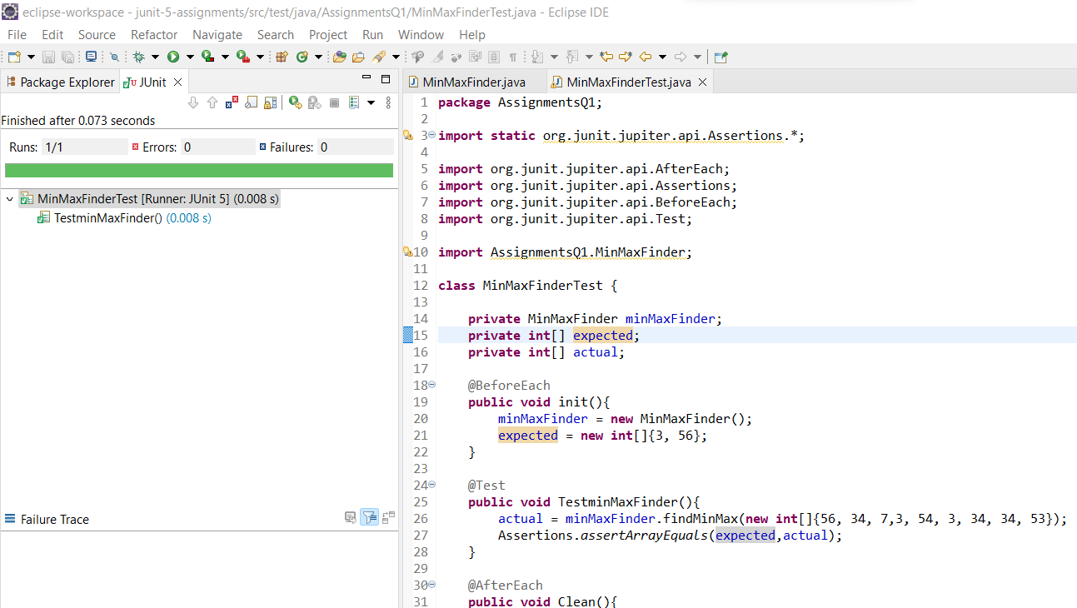

**Q2.** Modify the above method to return a single object representing min and max value of the pass array. Define new sets of Junit Test cases of this modified method.

**Created Main Class as well as Test class for the same:**

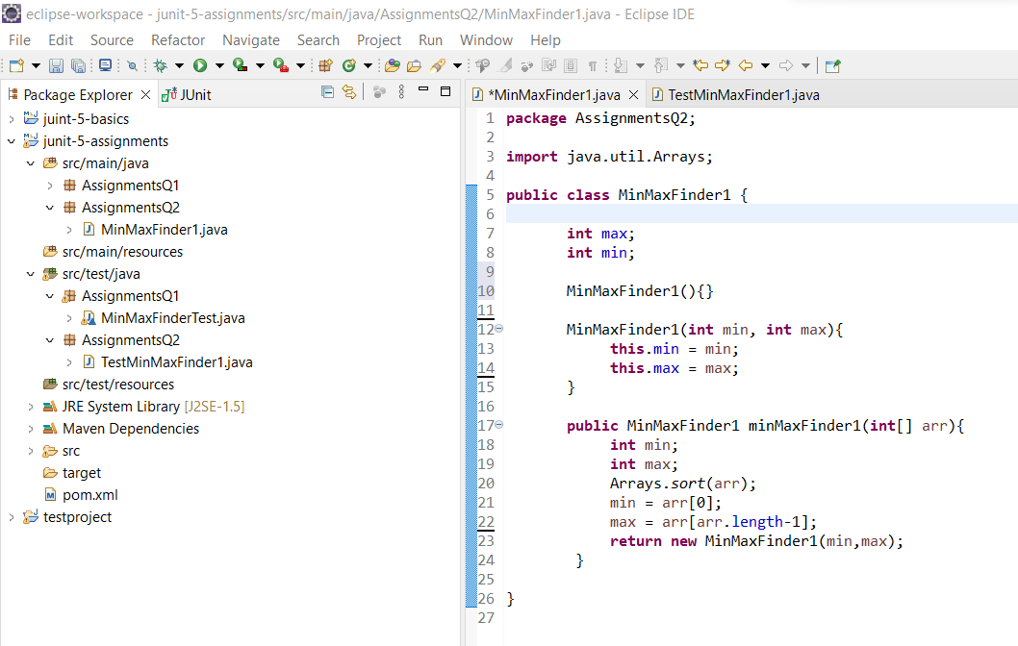

**Main Class Code:**

**package** AssignmentsQ2;

**import** java.util.Arrays;

**public** **class** MinMaxFinder1 {

**int** max;

**int** min;

MinMaxFinder1(){}

MinMaxFinder1(**int** min, **int** max){

**this**.min = min;

**this**.max = max;

}

**public** MinMaxFinder1 minMaxFinder1(**int**[] arr){

**int** min;

**int** max;

Arrays.*sort*(arr);

min = arr[0];

max = arr[arr.length-1];

**return** **new** MinMaxFinder1(min,max);

}

}

**Test Class Code:**

**package** AssignmentsQ2;

**import** org.junit.jupiter.api.*;

@TestMethodOrder(MethodOrderer.OrderAnnotation.**class**)

**public** **class** TestMinMaxFinder1 {

MinMaxFinder1 expected;

MinMaxFinder1 actual;

@BeforeEach

**public** **void** init(){

expected = **new** MinMaxFinder1(3,56);

actual = **new** MinMaxFinder1();

actual = actual.minMaxFinder1(**new** **int**[]{56, 34, 7,3, 54, 3, 34, 34, 53});

}

@Test()

@Order(1)

**public** **void** testMinFinder1(){

Assertions.*assertEquals*(expected.min,actual.min);

}

@Test

@Order(2)

**public** **void** testMaxFinder1(){

Assertions.*assertEquals*(expected.max,actual.max);

}

@AfterEach

**public** **void** Clean(){

actual = expected = **null**;

}

}

**Testing Output:**

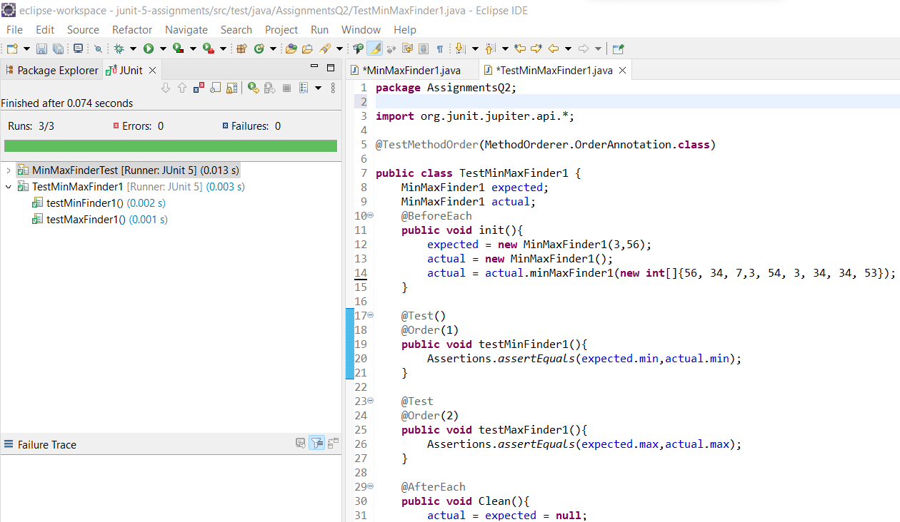

**Q3.** Write a BankAccount class with method withdraw which accepts amount to be withdrawn from the account (amount to be deducted from the balance of the account). In case there are insufficient funds a InsufficientFundsExpcetion should be raised. After defining the method perform Junit testing to check whether the InsufficientFundsException is raised when you try to withdraw amount that is over and above the account balance.

bankAccount.withdraw(20,000); should raise the InsufficientFundsException if the balance in the account is less than 20,000.

**Created Main Class, Test class and A Child Class Of Exception for the same:**

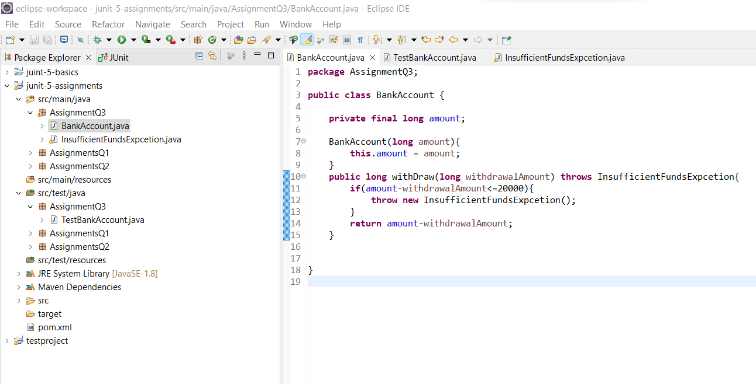

**Main Class Code:**

**package** AssignmentQ3;

**public** **class** BankAccount {

**private** **final** **long** amount;

BankAccount(**long** amount){

**this**.amount = amount;

}

**public** **long** withDraw(**long** withdrawalAmount) **throws** InsufficientFundsExpcetion{

**if**(amount-withdrawalAmount<=20000){

**throw** **new** InsufficientFundsExpcetion();

}

**return** amount-withdrawalAmount;

}

}

**Test Class Code:**

**package** AssignmentQ3;

**import** org.junit.jupiter.api.Assertions;

**import** org.junit.jupiter.api.BeforeEach;

**import** org.junit.jupiter.api.Test;

**public** **class** TestBankAccount {

**private** BankAccount bankAccount;

**private** **long** withDrawAmount;

@BeforeEach

**public** **void** init(){

//Initialize the Bank Amount;

bankAccount = **new** BankAccount(50000);

}

@Test

**public** **void** testBankAccount(){

withDrawAmount = 40000;

Assertions.*assertThrows*(InsufficientFundsExpcetion.**class**,()->{

System.***out***.println(bankAccount.withDraw(withDrawAmount));

},"YOU HAVE INSUFFICIENT BALANCE!!!");

}

@Test

**public** **void** testBankAccount1(){

withDrawAmount = 20000;

Assertions.*assertDoesNotThrow*(()->{

System.***out***.println("BALANCE AFTER WITHDRAWAL : "+bankAccount.withDraw(withDrawAmount));

});

}

}

**Child Extend Exception Class Code:**

**package** AssignmentQ3;

**public** **class** InsufficientFundsExpcetion **extends** Exception {

}

**Testing Output:**

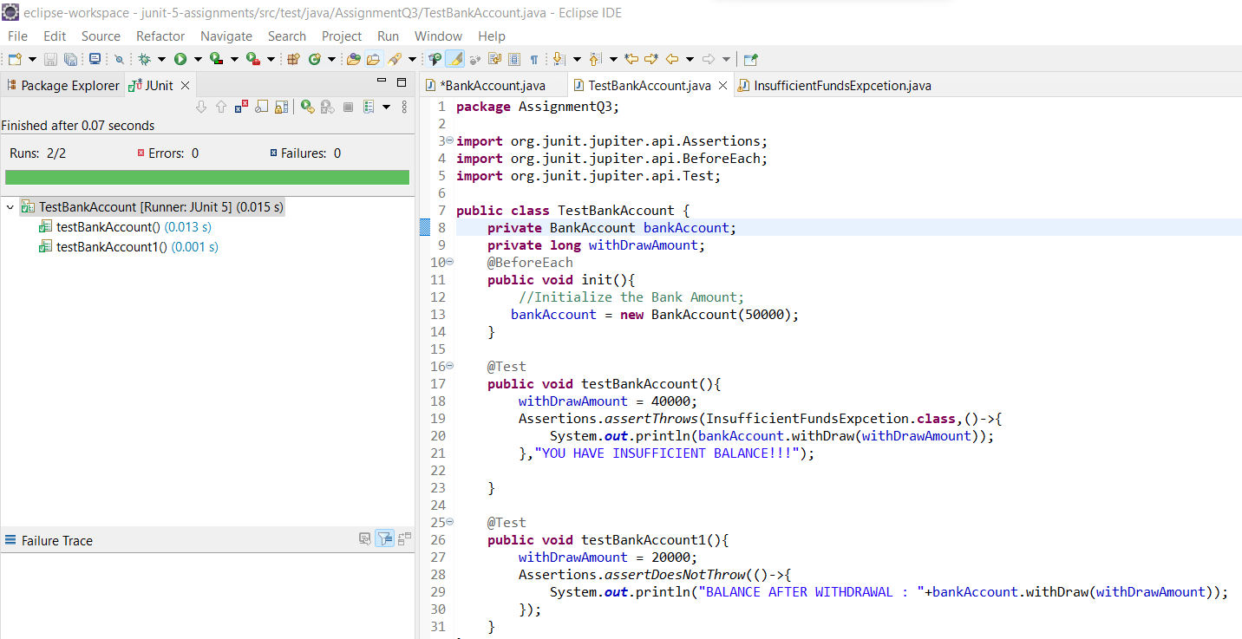

**Q4.** Write a Junit Testing to show the use of Lifecycle hooks annotation such as @BeforeAll, @BeforeEach @AfterEach and @AfterAll

**Test Class Code:**

**package** AssignmentQ4;

**import** org.junit.jupiter.api.AfterAll;

**import** org.junit.jupiter.api.AfterEach;

**import** org.junit.jupiter.api.BeforeAll;

**import** org.junit.jupiter.api.BeforeEach;

**import** org.junit.jupiter.api.DisplayName;

**import** org.junit.jupiter.api.Order;

**import** org.junit.jupiter.api.Test;

**import** org.junit.jupiter.api.TestInstance;

@TestInstance(TestInstance.Lifecycle.***PER_CLASS***)

**class** DemoTest {

@BeforeAll

**static** **void** meth1(){

System.***out***.println("BeforeAll - This will execute only once and before all the test methods. \n");

}

@BeforeEach

**public** **void** meth2(){

System.***out***.println("BeforeEach - This will always execute before all the test methods. ");

}

@Test

@Order(1)

@DisplayName("Method 5")

**public** **void** meth5(){

System.***out***.println("HELLO FROM TEST METHOD-1\n");

}

@Test

@Order(2)

@DisplayName("Method 6")

**public** **void** meth6(){

System.***out***.println("HELLO FROM TEST METHOD-2\n");

}

@Test

@Order(3)

@DisplayName("Method 7")

**public** **void** meth7(){

System.***out***.println("HELLO FROM TEST METHOD-3\n");

}

@AfterEach

**public** **void** meth3(){

System.***out***.println("AfterEach - This will always execute after all the test methods. \n");

}

@AfterAll

**static** **void** meth4(){

System.***out***.println("AfterAll - This will execute only once and after all the test methods. \n");

}

}

**Testing Output:**

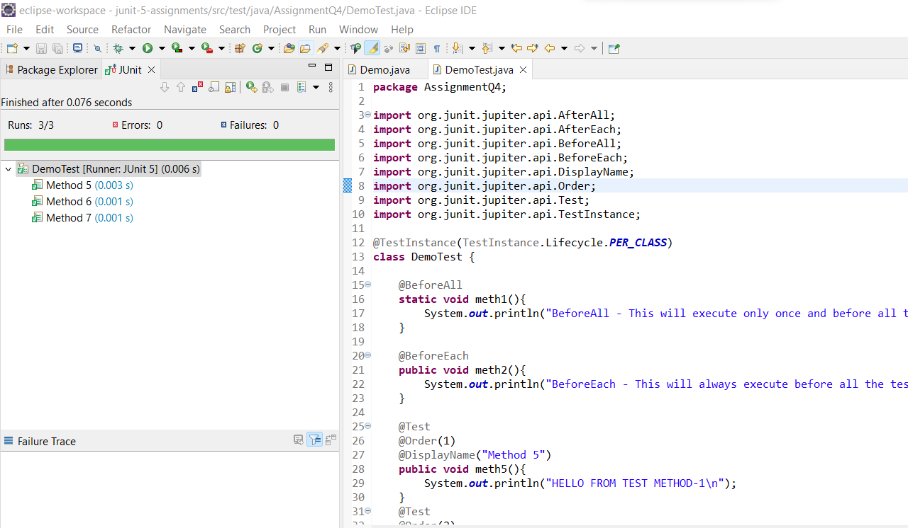

**Console Output:**

